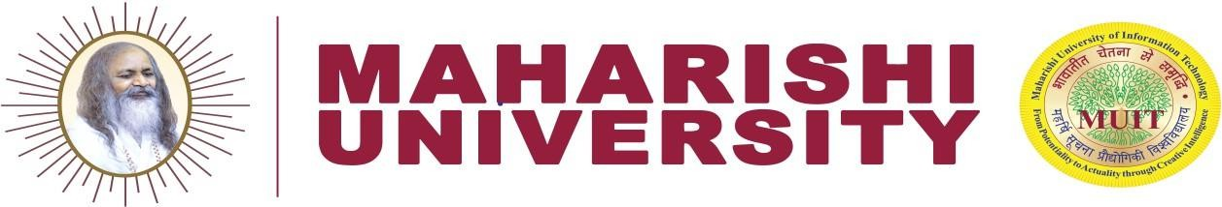
MAHARISHI UNIVERSITY OF INFORMATION TECHNOLOGY MAHARISHI SCHOOL OF ENGINEERING & TECHNOLOGY

Course Name – B.Tech 6th Sem
Data Mining Course Code- BCSE603
Assignment-1

Q1. Explain Knowledge Discovery in Databases (KDD) in Detail.
Q2. Discuss the major data mining tasks with suitable real-world examples (Predictive and Descriptive Tasks).
Q3. Explain the key issues and challenges in data mining related to data quality, scalability, and high dimensionality. Suggest suitable techniques to handle each challenge.
Q4. Define data mining metrics (matrices) used for evaluating classification and association rule mining models. Explain accuracy, precision, recall, F1-score, support, confidence, and lift with examples.
Q5. Given the following data ( in increasing order for attribute age: 13,15,16,16,19,20,20,21,22,22,25,25,25,25,30,33,33,35,35,35,35,36,40,45,46,52,70
- Solve this by using smoothing by equal- frequency i.e, bin by mean, bin by median, bin by boundary.
- Equal width Partitioning method
Q6. Suppose a group of 12 sales price records has been sorted as follows:
5,10,11,15, 35,50,55,72,92,204,215.
Solve by data partition by using k-means clustering where initial centroids are: C1-5,C2-60,C3-150
Q7. Analyze the social and ethical implications of data mining. How do privacy concerns, bias, and surveillance affect society?
Q8. Discuss the role of data preprocessing in data mining. Explain Binning technique in detail.
Q9. Explain types of attributes in data mining with examples.

